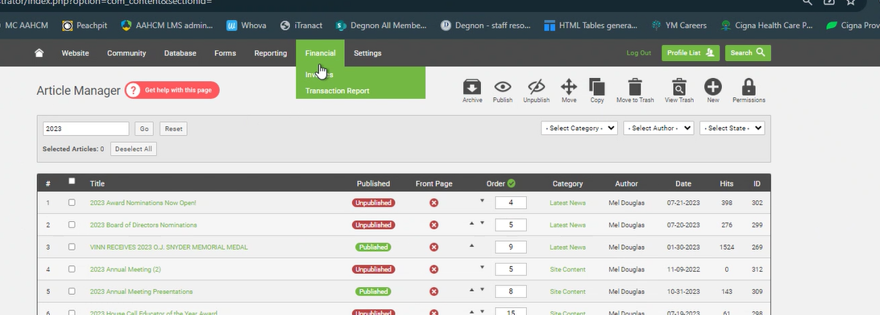
- Memberclicks/Financial/Transaction Report
- Choose Jan1 – Jan31 / Revenue Account = All / Transaction Type = Payments and Refunds / Payment Type = CC. Export CSV

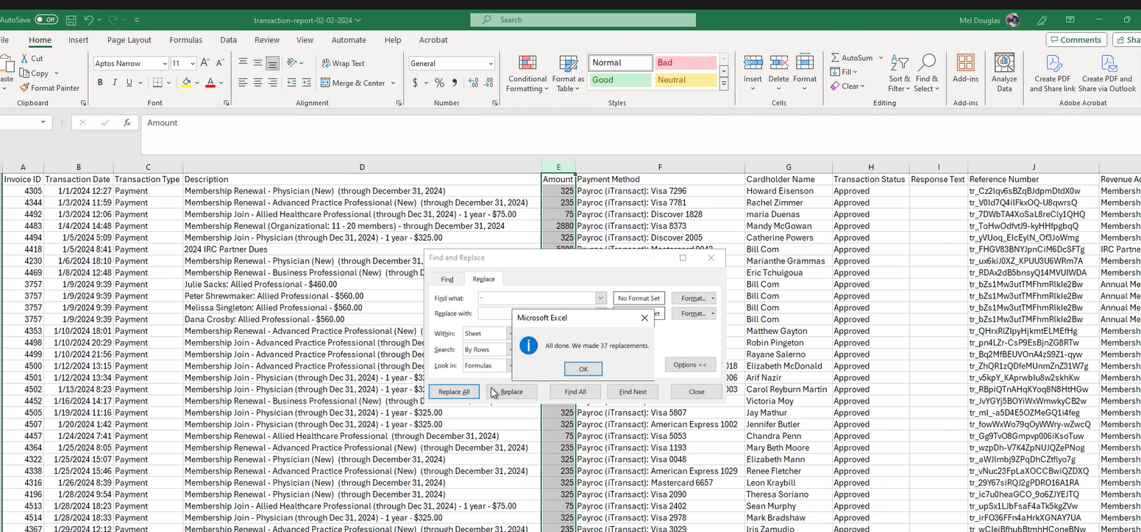
- Amount – change to positive and dollar amounts
- For refunds change back to negative and change text to red so it stands out

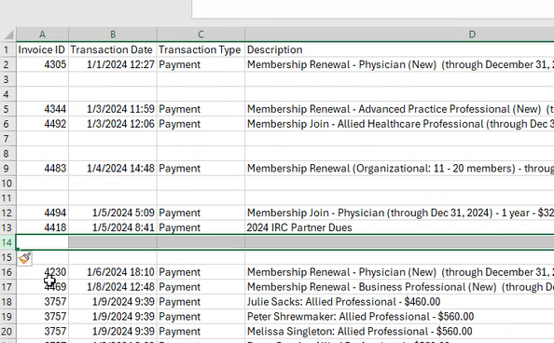
- Insert 2 lines between each date so it’s easier for Accounting to read
- To right of amount column, add 4 columns
  - Allocations (column F)
  - 2024 Dues (column G)
  - 2024 IRC Dues (column H)
  - 2024 Org Dues (column I)
  - Another column for Donations, Tom Cornwell Fund, Annual Meeting Sponsorship, etc etc
  - Last year – allocation for split dues – column for 2023 and 2024

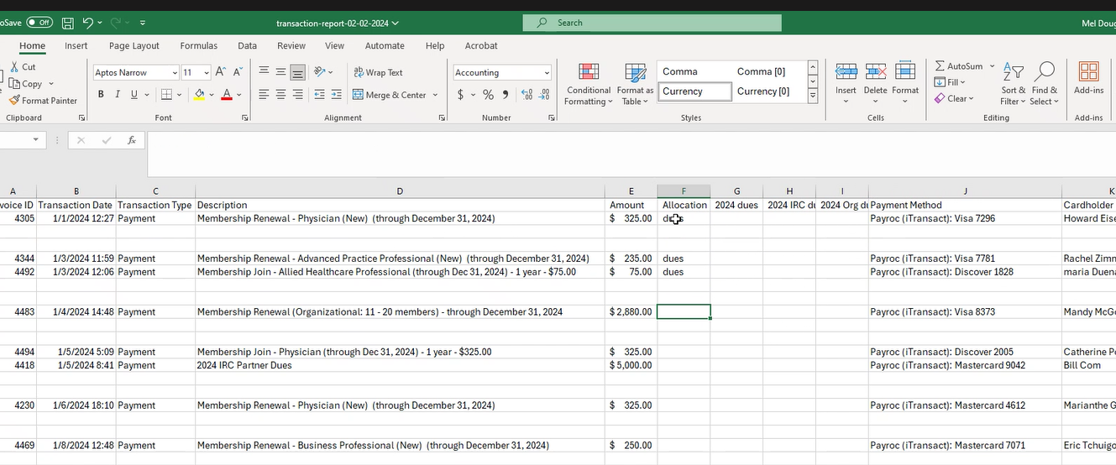
- Complete allocation column accordingly (dues, org dues, irc dues, AM Exhibitor). SAVE as excel workbook. AAHCM_CCJanuary2024 (acronym, underscore, CC for credit card, month year spelled out)

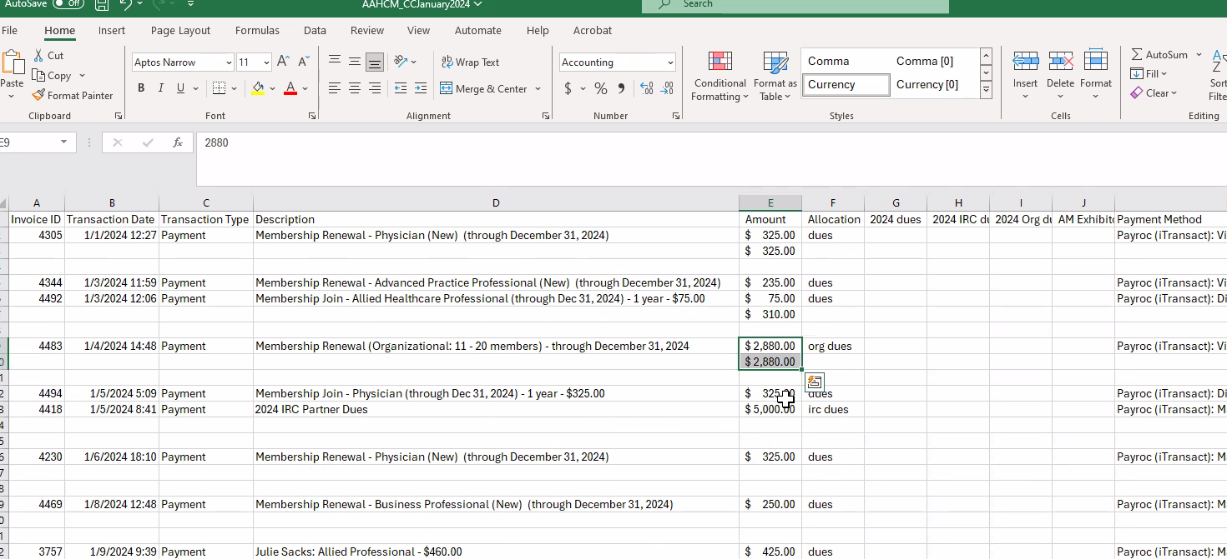
- Now, total amount for each day.

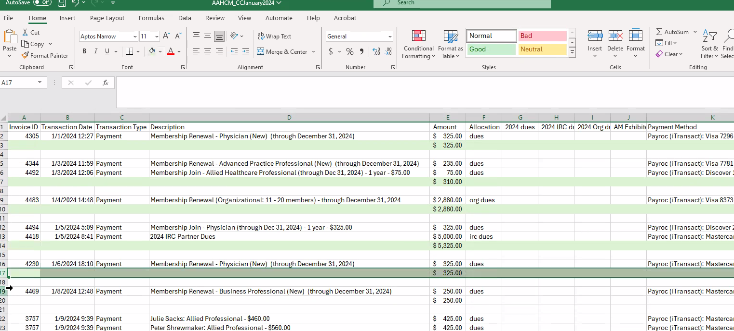
- Highlight the totals line and make light green
- Freeze top row

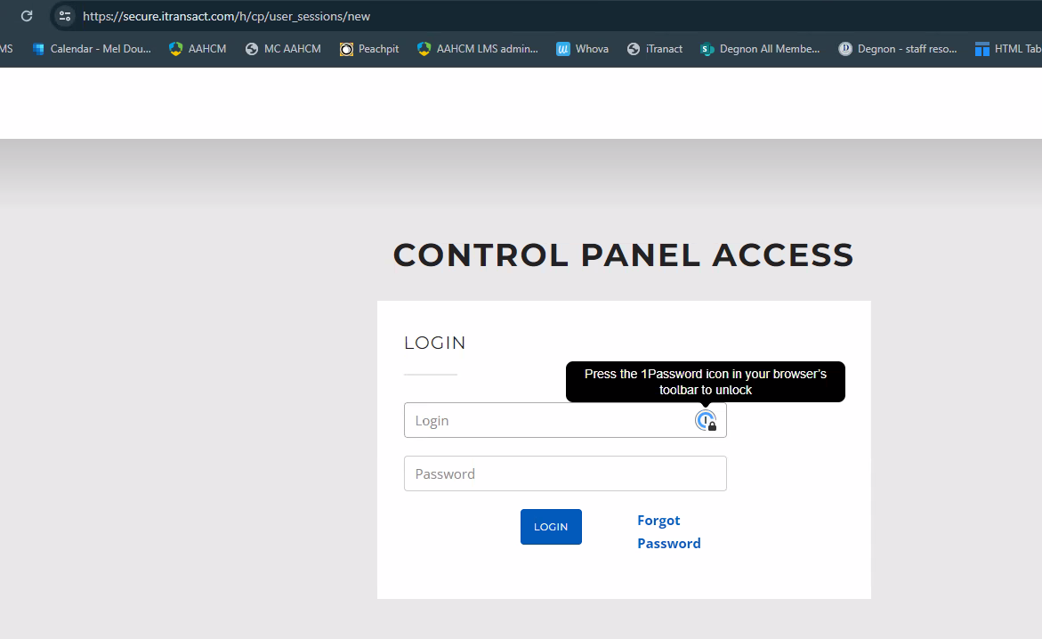
- ITransact (PayRoc)

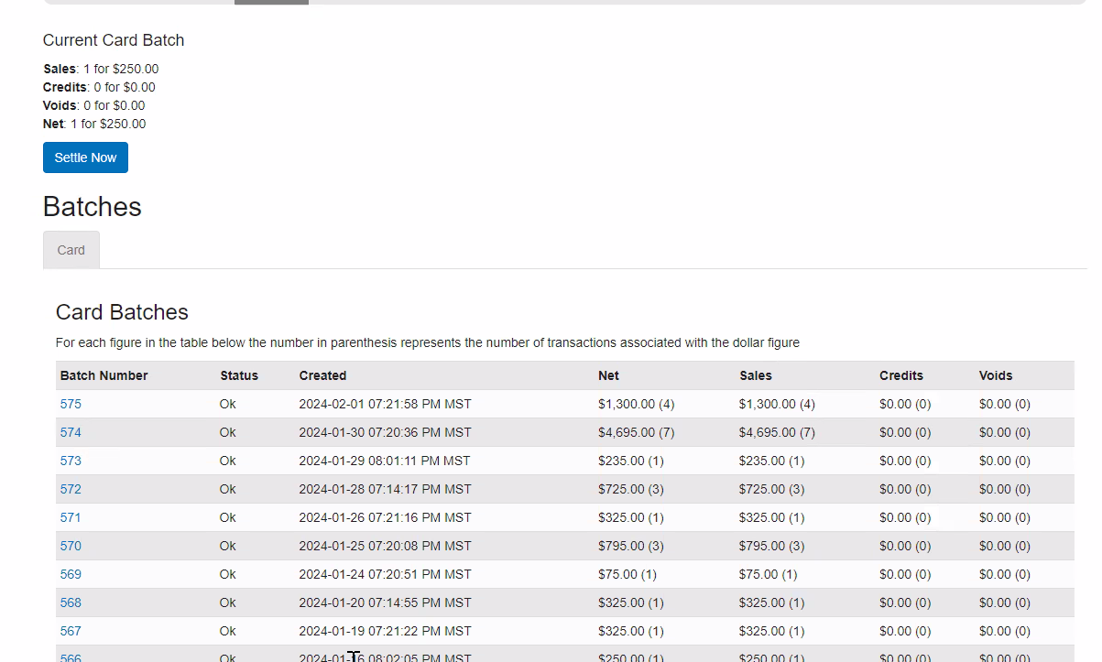
- Batches based on when cleared.
- Go back to Jan 1. Check against spreadsheet. Since both have 1 transaction they match.

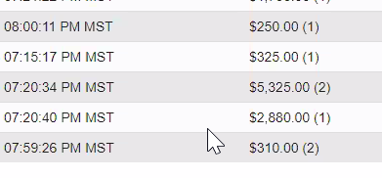
- Compare transactions to Payroc. Note cleared

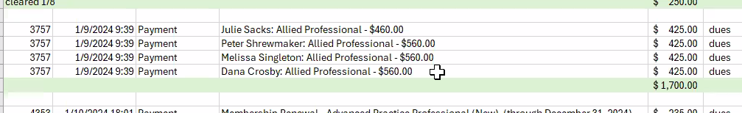
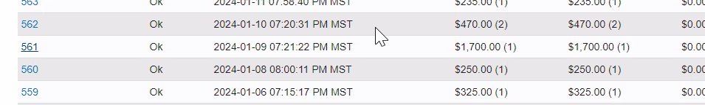
- Here is an example of where payroc says (1) transaction, our spreadsheet has (4). We can click on the transaction, compare total, compare credit card, and make sure they agree.

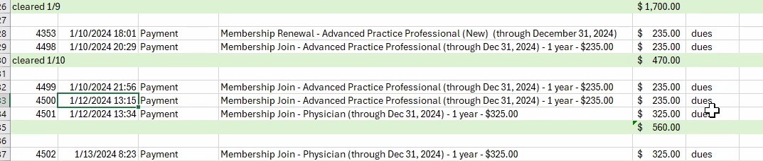
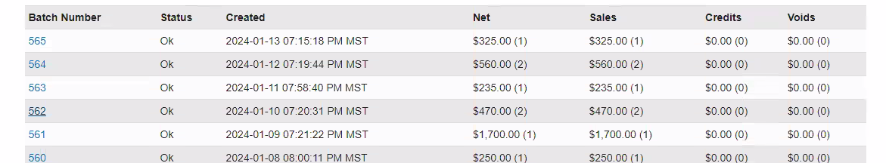
- In an instance where it was not included in Payroc, need to move the transaction to the next day and readjust the total for the next day.

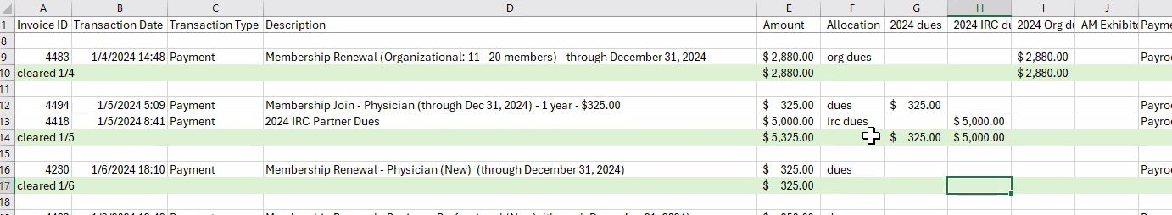
- Now copy amounts and totals to the corresponding account columns.

- Format Dollar Columns with $ sign

- Next – go to Sharepoint / AAHCM / Finances / Banking / Credit Card Batches 2025.
- Upload the spreadsheet.
- Email to Stephanie L & accounting@degnon.org & cc Cari Price (copy link and send the link)

